**Experiment Number:** ***9*** **Date**: 17/03/2011

**Current Commutated Chopper**

**Aim:**

To simulate the circuit of a current commutated chopper and verify its operation using MATLAB and Simulink.

**Components Required:**

The following components are required from the Simulink block-sets:

|  |  |  |  |
| --- | --- | --- | --- |
| **S.No.** | **Component** | **No.** | **Specification** |
| 1. | DC Voltage Source | 1 | 230V |
| 2. | Thyristor | 2 | - |
| 3. | Capacitor | 1 | 1µF, 230V |
| 4. | Inductor | 1 | 1mH |
| 5. | Diode | 3 | - |
| 6. | Series RL Load | 1 | - |
| 7. | Measuring Scope | 2 | - |
| 8. | Pulse Generator | 2 | - |
| 9. | Bus Selector | 2 | - |

**Description:**

A dc chopper circuit aims at a reduction in the average dc output voltage using on/off switching. The use of fully controlled switches (IGBT, MOSFET, power BJT) would not require any external commutation circuitry. However, if thyristors (SCR) are to be used, then the fact that they are semi-controlled makes the use of external commutation circuitry inevitable. This can be done in two ways.

1. Voltage Commutation
2. Current Commutation

In voltage commutation technique, the main thyristor is turned off by applying an instantaneous reverse voltage across it using an auxiliary thyristor. However, in current commutation method, the main thyristor is turned off by forcing the current flowing through it to fall to zero. This is done with the help of an LC circuit and an auxiliary thyristor. Current through the LC circuit builds sinusoidally, partially supplying the load current. When it builds to the extent that the complete load current is supplied through the LC circuit, then the main thyristor turns off. Since commutation is achieved using current as the controlled parameter, this method is named as current commutation.

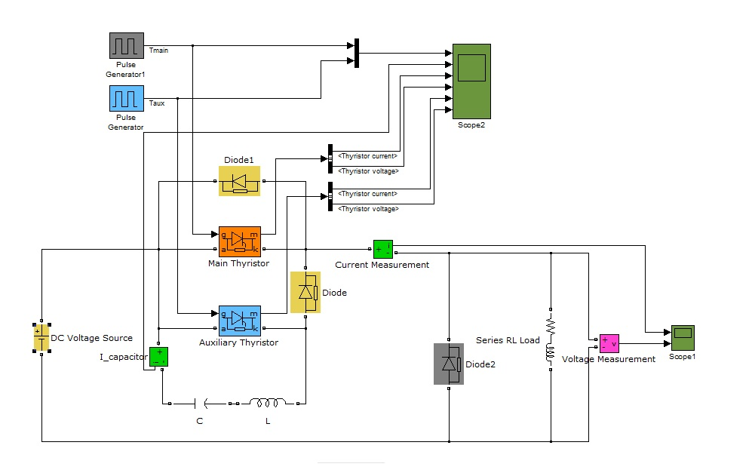**Circuit Diagram:**

**Working:**

Assume the capacitor is initially charged to *Vdc*. Gate of the main thyristor (*Tmain*) is now triggered. The circuit operates normally, with the load current flowing through *Tmain*. When it is desired to turn *Tmain*OFF, the gate of the auxiliary thyristor (*Taux*) is triggered. This closes the LC circuit, giving rise to sinusoidal current in the loop owing to the initial charge across the capacitor. However, *Taux* remains ON only as long as the sinusoidal current through it is positive. When it falls to zero and begins to increase in the negative direction, *Taux* turns off and the diode conducts. Since this sinusoidal current partially aids the load current, the current supplied by *Tmain*falls, eventually turning it OFF.

The diode1 is used for conducting the excess current from LC oscillations to enable soft-switching. Assuming constant conduction mode (CCM), the capacitor charges through a constant load current, and eventually opens up, hence completing the cycle.

**Output Waveforms:**

The various waveforms obtained after the simulation of the circuit are shown below. They include gate pulses to *Tmain*and *Taux*, current through the capacitor, current and voltage across the *Tmain* and *Taux*, over one cycle.

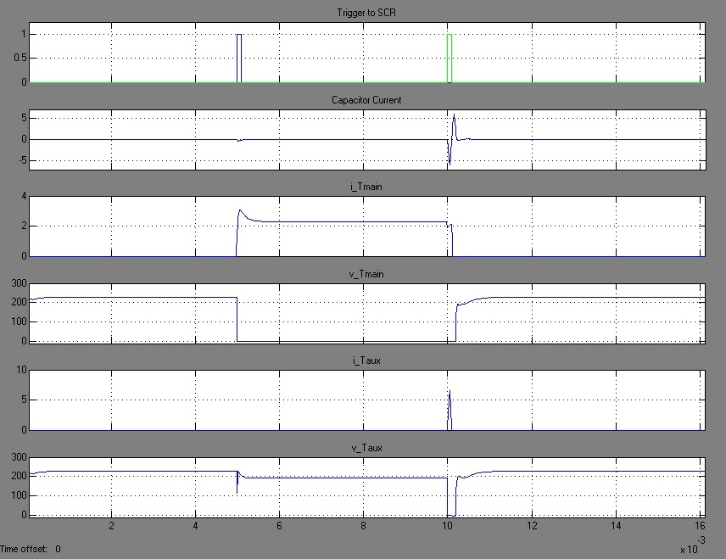

These waveforms portray the operation of the dc chopper in reducing the average output voltage using on/off switching.

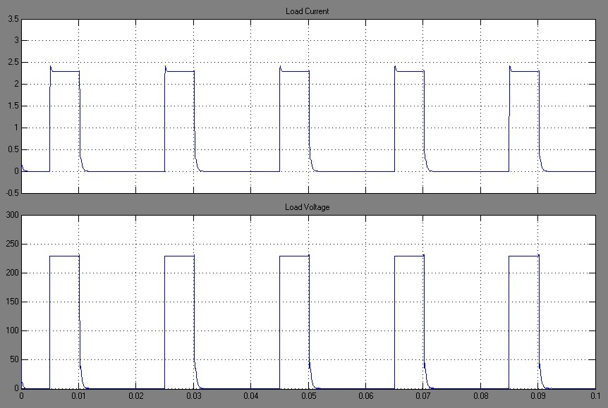

**Result:**

Hence the operation of a current commutated chopper is simulated and its working is validated by observing the respective output waveforms.

|  |  |  |  |
| --- | --- | --- | --- |
| **Simulation and Report** by,  Sambhav R Jain  S Vignesh  Anup Srivatsan  S P Jainaveen |  | Marks | Signature |
| Simulation |  |  |
| Output |  |  |
| Report |  |  |